# **IST769 Homework Submission**

Your Name: **Sathish Kumar Rajendiran**   
Your SUID: **666555028**  
Your Email: **srajendi@syr.edu**  
Date Due: **07/13/2021**    
Homework #:**1**

## **Instructions**

For each answer, please include your answer as text, and any screenshot(s) which demonstrate your answer was executed. Most importantly, make sure to include evidence your answer is correct. This will most likely be a screenshot. If you had issues, problems, or had to make assumptions include them in your answer.

# **Exercise(s):**

1**. What would be the command to bring up the redis environment? How is the command different from the mssql environment? How is it the same?**

**Evidence:**

* 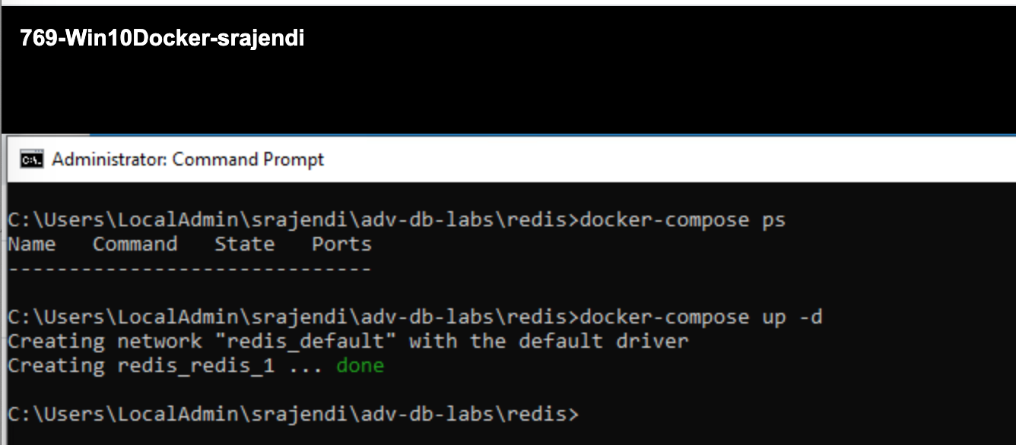
* 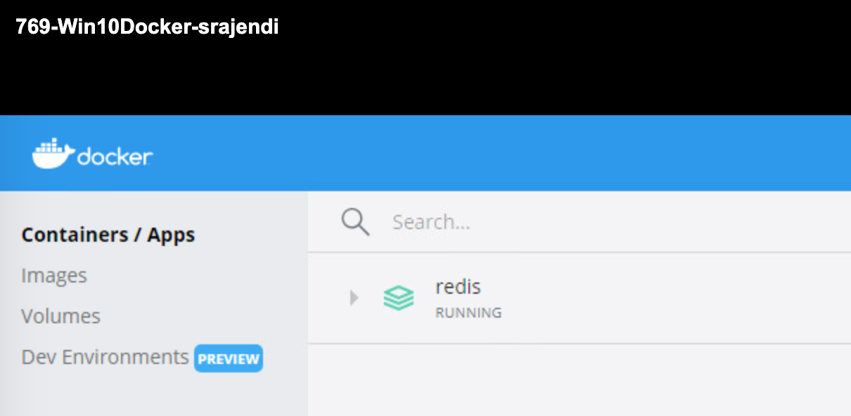
* 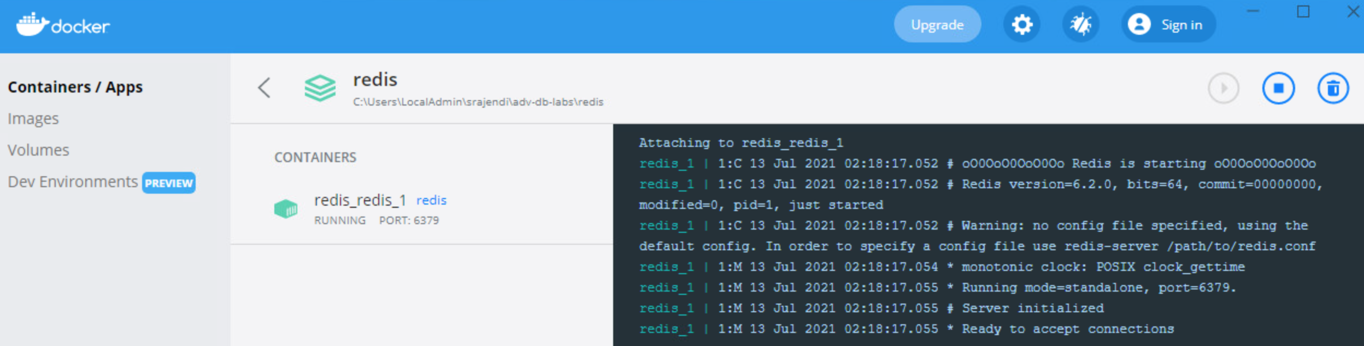
* 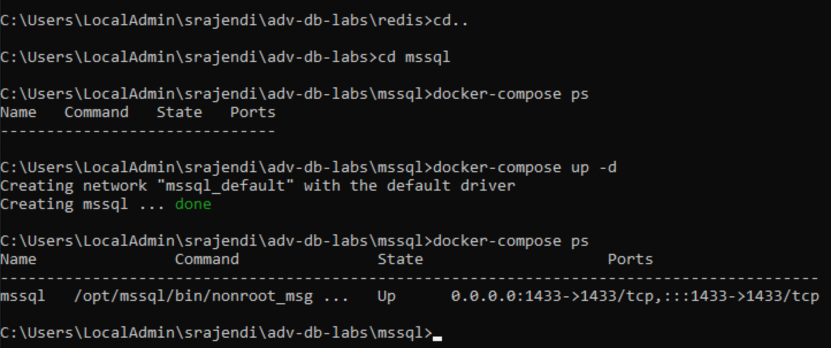
* 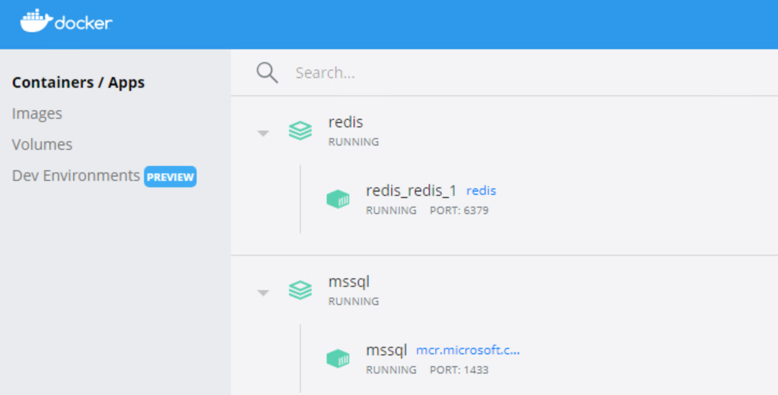

2**. Where is the specific configuration information about each environment stored?**

Configuration information about each environment is stored in “**docker-compose.yml**” file under respective components/services folder.

* 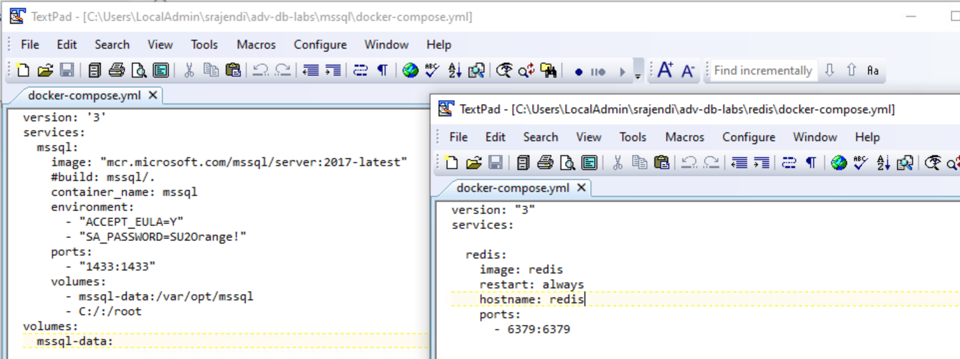

**3. Explain the difference between stopping an environment and bringing it down. Elaborate with use-cases for each.**

* Stopping an environment:
  + Docker command: **docker-compose stop**
  + 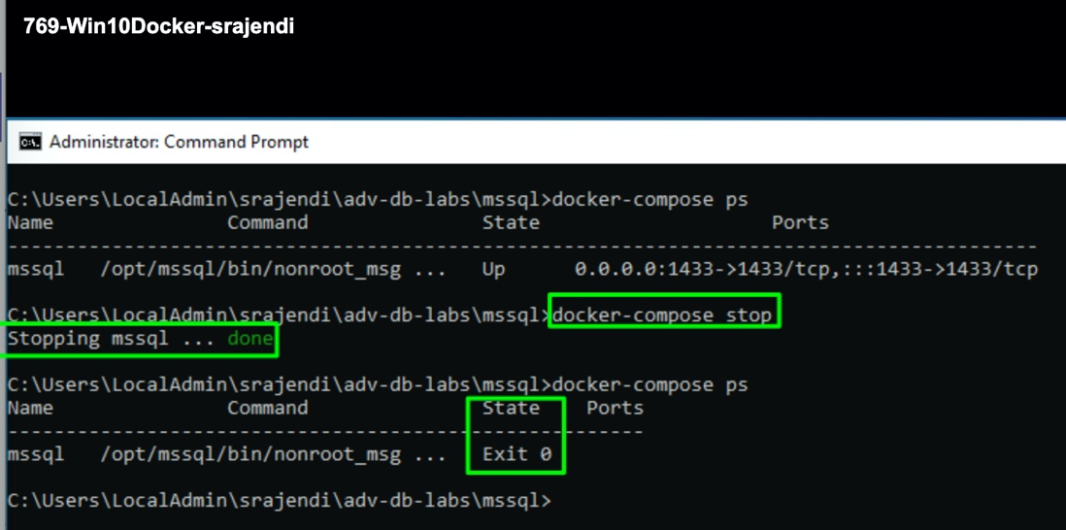
* 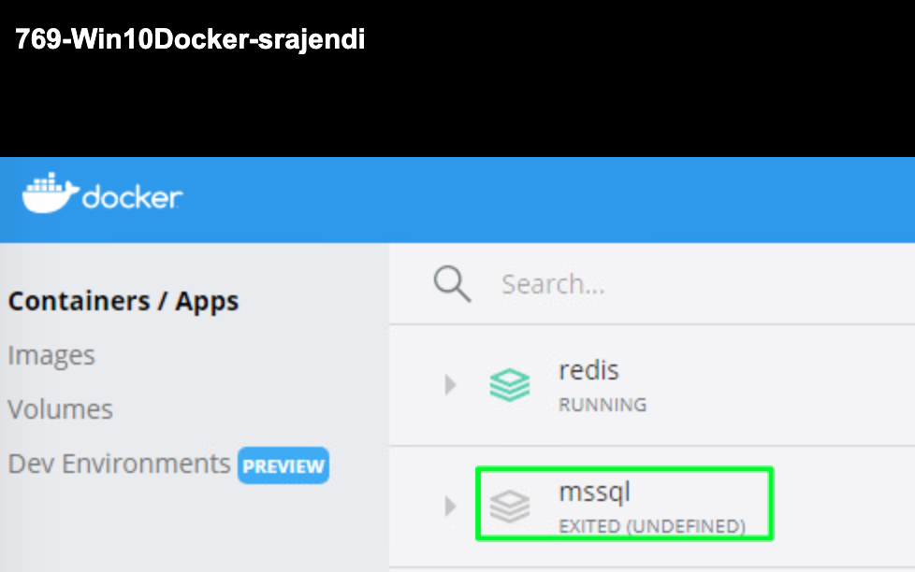
* bringing it down: **docker-compose down**
  + 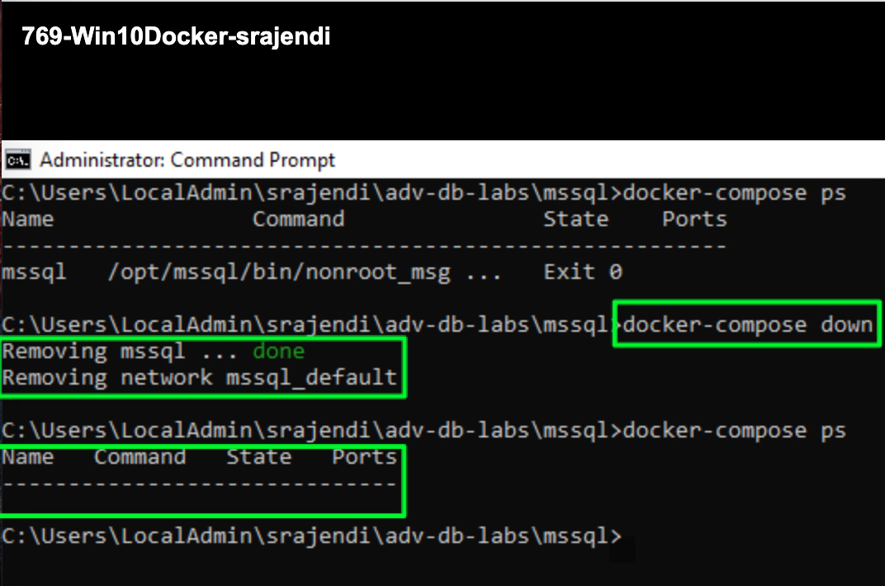
  + 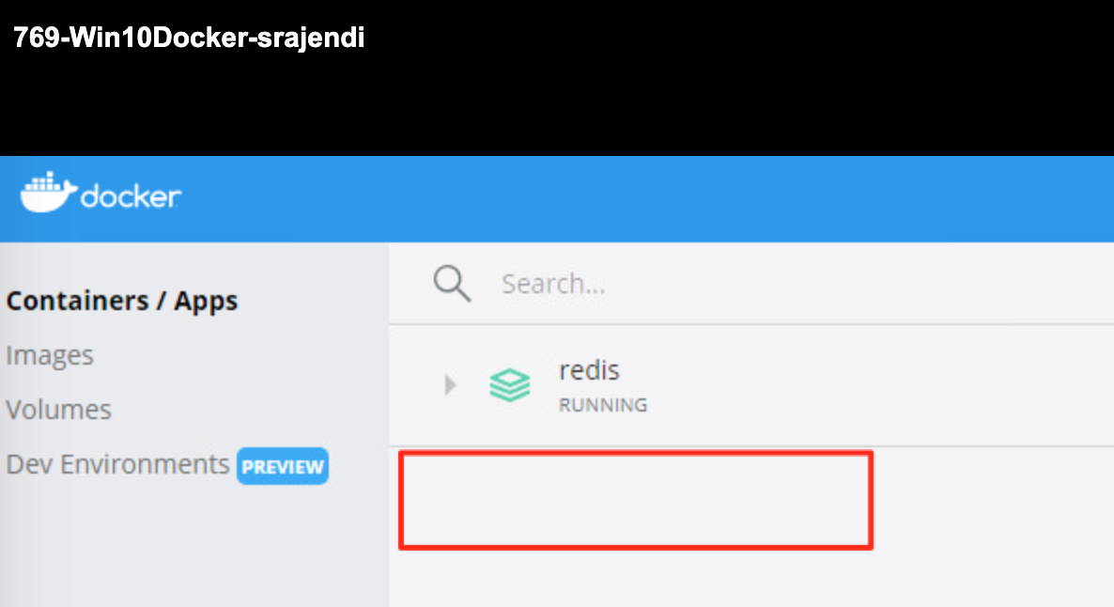
  + 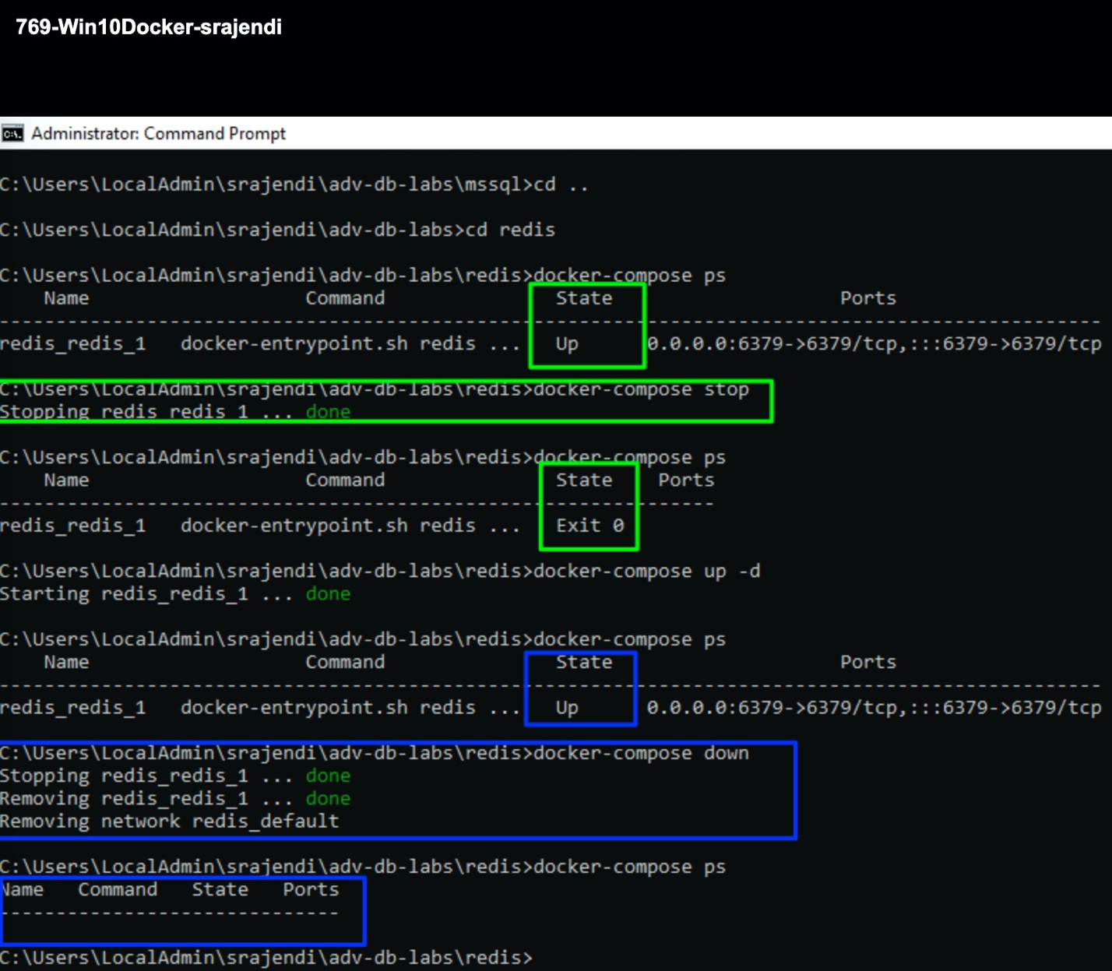

4. **What happens when you bring up an environment that is already up?**

* start the service: **docker-compose up -d**
  + 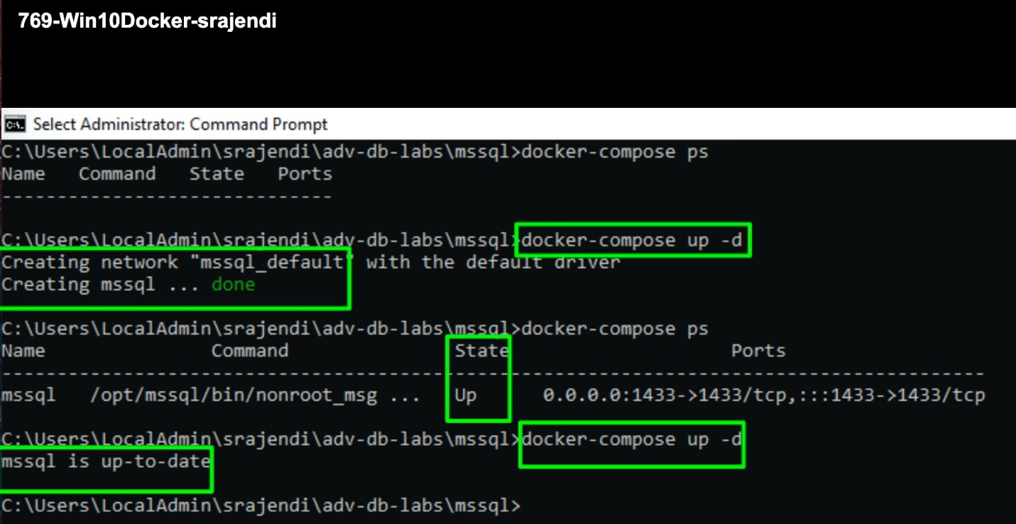
  + 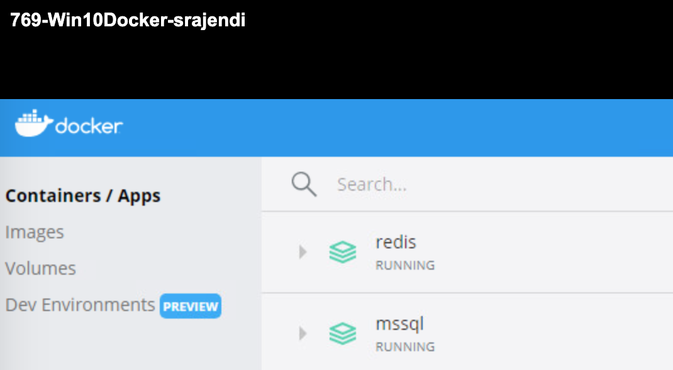

**5. What was the most difficult aspect of this lab? What changes could be made to make it less difficult?**

I don’t think it was challenging. Maybe it would have been better if we had few hands on for Redis. I personally haven’t used Redis database in the past. Only other challenge was with mssql image version. But one of the students had mentioned about the workaround to fix it. So, it was quite straightforward.

As long as vlab instance on iSchool – I am quite comfortable with this exercise. However, I would like to try to the same on my mac machine. I am not a huge fan of SQL Workbench. So, preferred MSSQL on the vlab.

**Appendix:**

